Business Course Essay
Name
Institution
STARBUCKS ORGANIZATION CHART
Organizational Structure; Management & Staffing
Organizational Chart
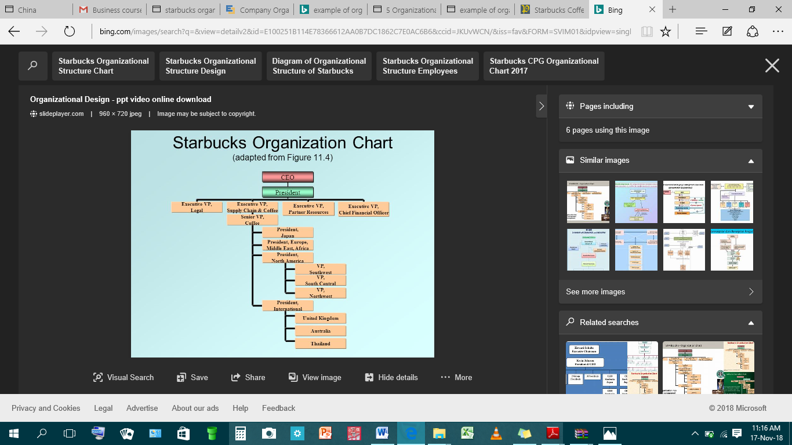
Rationale for the Matrix Structure
Starbucks coffee company in Poland makes use of its organizational structure to ensure that all business operations both within the host country and the global market are well managed. Throughout years, the company has ensured to maintain a good global relationship with other companies so that its market may not deplete. It also maintains a corporate structure that enables it to maintain industry leadership in the global market (Meyer, 2018). Also, its organizational structure is known to influence its business in various aspects such as communication, leadership, management, change of strategies and business in general. In this case, the company has to evolve to ensure that its organizational structure is well fit for its business operations with other countries overseas as well as match all of its current business requirements and needs.
In the previous year, Starbucks was able to change its business and organizational structure especially after it acquired some other firms the likes of Seattle’s Best Coffee and Ethos Water. These acquisitions makes the company to maintain a stable organizational structure that looks up to the needs of the business in general. I therefore chose the matrix organizational chart since it fits within all the conventions of the different typologies of the businesses as well as the organizational structures (Meyer, 2018). Also, this kind of organizational chart also ensures that other companies are able to employ their structural characteristics so that each and every business operation is carried out smoothly without any challenges of improper management.
The company has therefore always supported and uplifted its competitive advantages because they help it to operate as a corporate structure. These competitive advantages enable it to interact with other firms throughout the world and build its industry environment which entails stronger forces of competition. Its competition is portrayed through other companies which are either in the coffee or food business. For example, Dunkin Donuts, Burger King and Wendy’s represent some of the highest competitors from around the world (Meyer, 2018). However, besides the company facing strong competition from these companies, it uses its organizational structure to ensure that it grows and makes it to the international market.
The above matrix organizational structure is fit for Starbucks Company because it represents a mixture of different aspects from the structural design. For instance, it ensures to apply different intersections of business components which helps it to base its production through divisions which are geographically sensitive. It also shows how the different staffs work in teams to ensure that success of the oversea business operations is attained (Meyer, 2018). This is majorly through applying major components which are highly considered and these include geographic division, product-based divisions, functional hierarchy and teams.
Staffing policy and Rationale
The staffing policy I would recommend for the top-level managers includes various prospects that must be fulfilled. For example, the top managers include military spouses and parents. Hence, there is a need to implement staffing policies that are going to favor these top managers so that they can be motivated to work hard towards achieving the company’s goals and objectives. For instance, the company is entrusted with the role of helping the top managers to perform excellently through their delegated roles and responsibilities. For instance, if the top managers engage in work for 20 hours or more, there is need to grant them some benefits that are going to motivate them achieve their goals (Starbucks Corporation, 2018). For example, they will be granted healthcare coverage, equity which comes in the form of Starbucks stock and lastly a debt-free university degree to be undertaken through the Starbucks college achievement plan.
Additionally, the staffing policy also allows all managers to be assisted with the achievement of personal obligations so that they can find a way to balance their interests with those of the company. For instance, the policy would ensure that flexibility and consistency is fully applied so that all managers can be treated from an individual approach as it improves their overall performance. With these benefits, the top managers will now be able to make corporate decisions and design strategies through which they can enable the company to maintain its international relations and ties (Starbucks Corporation, 2018). All top managers especially those that are in charge of the stores are also important because they determine the normal seasonality of the company’s business operations and ensures that all customers shift their interests and behaviors towards purchase of the company’s products.
Lastly, I recommend this type of staffing policy because it enables the top managers of the company to realize their worth and learn that the company is happy to have them. Employee appreciation also evokes motivation and this is a positive thing since it leads to a better performance. Also, the policy would allow the human resource department to take care of the needs of the top managers so that they can feel at home whenever they are at the premises of the company because they are highly treasured and appreciated (Starbucks Corporation, 2018). Also, this allows the right partnership and relationship to grow and develop between the company and the top managers. A strong relationship therefore contributes to the achievement of the company’s goals and objectives especially those that involve business operations with other oversea companies.
Leadership and Motivational Systems
The leadership and motivation system that is effective for Starbucks in Poland is the organigraph. This is a more revealing system which will help Starbucks Company to depict al of its operations and people around the organization. For example, for leadership styles to be successful, an organization is required to first understand its employees so that it can learn the best techniques to apply for leadership to be achieved (Mintzberg & Heyden, 2018). For instance, the top managers will be required to ensure that their skills and expertise are also on a top level so that they can implement the best techniques to lead the rest of the employees. In this case, there needs to be an amicable relationship between the employees together with the managers. This ensures that all leadership and motivational systems applied are successful.
The organigraph also represents a map that shows all the functions of a company and the way organization is carried out in the company. For example, this system will help the top level managers at Starbucks to lay down all functions and responsibilities of employees so that they can enjoy the benefits such comes with. Also, the system can help managers to realize all the trapped opportunities there may be especially when it comes to the application of leadership and motivational systems (Mintzberg & Heyden, 2018). The employees in this case can be best motivated through introduction of incentives and promotion. Incentives in this case can come in the form of increment in salary while the promotion grants an employee a higher rank in the company. Hence, these are the best leadership and motivational systems that will best suit Starbucks at its environment.
Conclusion: Future Outlook of Starbucks
Concerns of the Host Country and the Local Community
Starbucks Company has decided to install more stores in Poland so that it can keep up with the level of competition. In this case, it is important that the company employs more employees who are well trained on how to carry out the roles and responsibilities of the company. Through this, it can be assured to emerge out successfully within its new environment. The host country Poland in this case definitely has concerns through which it would want to learn more of the benefits it is going to attain from Starbucks being part of it. A major benefit is that the country will continue to attract foreign direct investment since Starbucks is an international country.
Also, the level of competition will be high especially in the coffee and food industry. This is an advantage to the host country as it will gain more opportunities of customers enjoying the best quality of products which can easily satisfy their needs. Also, the country will benefit from the creation of employment opportunities from Starbucks Company. This is because it will require hiring new employees who can help in the achievement of its goals and objectives.
Additionally, the local community at Poland will also be concerned especially with the introduction of the new products from Starbucks Company. They will be overwhelmed as they will get to enjoy the best quality of coffee from Starbucks which is an international product. Also, more customers will be happy to change their preferences and enjoy products at Starbucks Company. The residents who will gain employment opportunities will be happier since they will now be able to make a living without many difficulties. This will in the end will improve the economy of Poland and enable it to strengthen its international ties with other countries overseas.
Plans to deal with Concerns
I therefore have planned to respond positively to the concerns of both the host country as well as the local community members. First of all, I will ensure to create a positive relationship with the state government since they play a major part in the business operations of Starbucks Company. This is because the company will have introduced more international ties within the country and therefore the state government will be quite impressed. Additionally, I will ensure to create employment opportunities to the community members so that they can be part of the Starbucks team and work towards attaining their personal obligations as well as those of the company. This is because it is important to make use of local resources as a way of promoting the country’s economy. I will also set up a training center where all the recruited persons will undertake their training programs so that they may be at per with the attainment of all roles and responsibilities that will be given to them.
Lastly, I will introduce new policies that are friendly both to the host country as well as to the community members. The first policy is to ensure to always put all customers as the first priority of the company. This is to ensure that customer satisfaction is fully achieved. It will continue to attract more customers to the products of the company which is an added competitive advantage over Starbucks’ competitors. These actions therefore will be implemented with the least time possible so that Starbucks Company can maintain a good long term corporate relationship with the host country.

References
Meyer, P. (2018). “Starbucks Coffee’s Organizational Structure & Its Characteristics.” Panmore Institute.
Mintzberg, H. & Heyden, L. V. (2018). “Organigraphs: Drawing how Companies really work.” Research Gate.
Starbucks Corporation. (2018). “Starbucks Approach to Staffing and Scheduling.” Starbucks Corporation.

